 | 13.1.17 Editors - Shader Editor - Header - Node menu
Table of content
Node menu 2
Move 2
Rotate 2
Resize 2
Cut 2
Copy 2
Paste 2
Duplicate Keep Input 2
Duplicate 2
Duplicate Linked 3
Delete 3
Delete with Reconnect 3
Join in new Frame 3
Remove from Frame 3
Join Group Inputs 3
Join in Named Frames 3
Frame Make Parent 3
Rename 3
Group submenu 3
Make Group 3
Insert into Group 5
Ungroup 5
Toggle Edit Group 5
Links submenu 5
Make Links 5
Make and Replace Links 5
Cut Links 5
Detach Links 5
Detach Links Move 5
Mute Links 5
Separate submenu 6
Copy 6
Move 6
Show/Hide submenu 6
Collapse 6
Toggle Node Mute 6
Toggle hidden node sockets 6
Toggle Node Options 6
Collapse and Hide Unused Sockets 7

Node menu
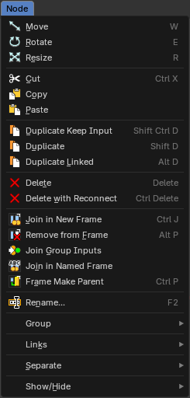
This menu contains further node functionality.

Move
Moves the selected nodes.

Rotate
You can't rotate single nodes, obviously. But when you have more than one selected then you can rotate them around their center point.

Resize
You can't resize single nodes, obviously. But when you have more than one selected then you can scale them around their center point.

Cut
Cuts the selected node(s) and copies to clipboard, then removes it from the current material node setup, while reconnecting any nodes links that were connected.

Copy
Copies the selected node(s) to the clipboard, for reuse with the paste operator in the current or other instances of Bforartists that are open.

Paste
Pastes the selected node(s) from the above mention copy operator that are in the clipboard, in the current session of Bforartists or another instance that are open.

Duplicate Keep Input
This works at nodes that have a connected input. Duplicating will keep the input connections established in the duplicated node. The output connections will be removed.

Duplicate
Duplicates the selected node(s). All connections will be removed in the duplicated node.

Duplicate Linked
Duplicates the selected node(s). But not their node trees. And move them.

Delete
Deletes the selected node(s).

Delete with Reconnect
Deletes the selected node(s). When this node is in the middle of a connection, then the connections will be reconnected.

Join in new Frame
Frame node functionality. Adds the selected node to a frame.

Remove from Frame
Frame node functionality. Removes the selected node from a frame.

Join Group Inputs
Merge selected group input nodes into one if possible.

Join in Named Frames
Create a new frame node, and name it immediately.

Frame Make Parent
Frame node functionality. Adds the selected node to a frame.

Rename
Rename the selected node.

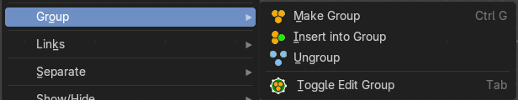
Group submenu

Make Group
Groups the selected nodes together.
Select the nodes that you want to group together. Choose Make Group. You will now see a green background. This indicates that the group is created, and that you are in edit mode for the group now.




To exit the group edit mode press Tab key, or choose Toggle Edit Group menu item in the sidebar in the Relations tab in the Group panel. That way you can also enter the Group Edit mode again.




There is a third way to enter the group edit mode. Click at the right upper icon of the group node.


A group can be further collapsed by clicking at the triangle button in the upper left corner.


The group can be renamed in the sidebar in the Item tab and in the Properties tab in the Node panel.

Insert into Group
Allows you to insert a node into a node group.
Select the node, hold down Shift, then select the node group so that both are selected. Then perform the operator.

Ungroup
Ungroups an existing group. You need to be outside of the group edit mode.

Toggle Edit Group
Enters a node group for editing. Or when you are in a node group, exits the node group editing.

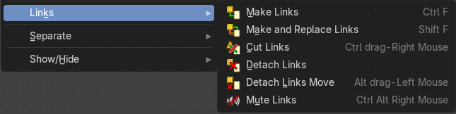
Links submenu

Make Links
Tries to connect nodes where it makes sense. For example, the BSDF output of a Principled shader with the Surface input of the Material Output node.

Make and Replace Links
Same as Make Links. But it will replace existing links.

Cut Links
Cut the links under the mouse.

Detach Links
Removes all connections from the selected node, but tries to reconnect the remaining nodes.

Detach Links Move
Removes all connections from the selected node by dragging.

Mute Links
Mute the links under the mouse.


Separate submenu
Node group functionality. You need to be in edit group mode.

Copy
Copies the selected node, and pastes a copy of it outside of the node group. The node group remains unchanged.

Move
Moves the selected to outside of the node group, and removes it from the node group.

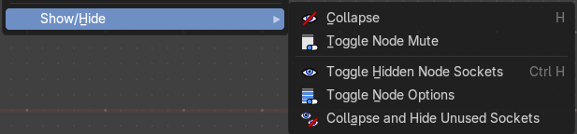
Show/Hide submenu
Here you find hide options to make the display of nodes more compact.


Demonstration happens at an image node.


Collapse
Hides everything but input and output dots. To view the full node again perform the operator again. It's a toggle. Or click at the triangle left besides the node name.

Toggle Node Mute
Deactivates the node.

Toggle hidden node sockets

Toggles away the unused node sockets. In this case the vector input node socket and the alpha output node socket will be hidden.


Toggle Node Options
Hides away the properties.


Collapse and Hide Unused Sockets
Like Hide. Hides everything but the node sockets. But it also hides the unused node sockets.

